**BEARING LIFE TIME EXPANDANCY**

**PROJECT REPORT**

**SUBMITTED BY**

**SHYAM GURUNATH.R K 17BAU027**

**DHINAKARAN.M 18BAU315**

**KESAVAN.A 18BAU326**

**UNDER THE GUIDANCE OF**

**Dr. R. Sunil Ganguli M.E., PhD**

**LECTURER, HEAD OF THE DEPARTMENT/AUTOMOBILE ENGINEERING**

***in partial fulfillment for the award of the degree***

***of***

**BACHELOR OF ENGINEERING**

**In**

**Automobile Engineering**

**Dr. Mahalingam College of Engineering and Technology**

**Pollachi – 642003**

**An Autonomous Institution**

**Affiliated to Anna University, Chennai – 600 025**

**September 2020**

**CONTENTS**

|  |  |  |
| --- | --- | --- |
| **CHAPTER.NO** | **TITLE** | **PAGE.NO** |
|  | **ABSTRACT** | **1** |
| **1** | **INTRODUCTION** | **2** |
| **2** | **METHODOLOGY** | **3** |
| **3** | **STEP BY STEP PROCEDURE** | **4** |
| **4** | **CONCLUSION** | **5** |

**BEARING LIFE TIME EXPANDANCY**

**ABSTRACT**

**In a deep groove ball bearing first of all to select a bearing and to find out the radial load, axial load, equivalent load and then find out the life ratting factor of bearing. Designer can design a good life of bearing by using this calculation.**

**Designer are design a 100% of bearing but only 90% of bearing will be successful and 10% of bearing will be failure. The manufacture recommendation is to design a 100% of bearing to 99% of bearing will be successful to ask to designer. This one not easy for designer it’s very difficult to given output 99% of bearing become succeed and then given to user. The lots of steps involved to calculate and give good reliability given to the user this takes more time. That’s why we are plan to create a software by using python programmed in a method of web application to easy to expand bearing life time.**

**In this project the user can directly use this software. User will install this software and then easily to find out the capacity of bearing by user. That’s the advantage of this software.**

**After software will install by user then user can put all input data of bearing. And then automatically calculated and find out the capacity of bearing for user recommendation.**

**1**

INTRODUCTION

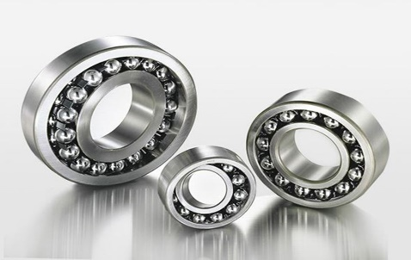Deep groove ball bearing is the most common type of ball bearing. They are commonly used in electric motor and in household appliance, car motors, office machinery, automation control, and garden and household tools. They have deep raceway grooves and their race dimensions are close to the dimensions of the balls that run inside.

Fig-1

Deep groove ball bearing come in many sizes, material and varieties according to consumer needs, including special industrial uses such as high-temperature applications. High temperature bearing is made to withstand temperatures up to 350⁰ (660⁰F) and are suitable for machines used in the metals industry or for industrial ovens.

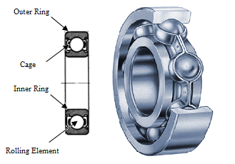

Fig-2

Deep groove ball bearing is among the most widely used type of bearing in the world. They can operate at high speeds and can carry radial and axial loads. They are commonly used in electric motors, compressors, fans, and conveyors.

Deep groove ball bearing is a common type of bearing and it is used in several industries from heavy machinery to high precision apparatus. This type of bearing consists of four elements that include inner ring, outer ring, cage that holds balls and ball bearings. Because of the flat surface on outer ring and inner ring, Deep groove bearings provides a large area of contact that delivers high performance and high load capacity. Although Deep groove ball bearing come in hundreds of models and sizes with different design and even different material used in inner ring, outer ring and cage but basically, they are categorized in 4 main sections.

2

**METHODLOGY**

In a deep groove ball bearing three steps are used in this methodology they are

Step 1: Selection of bearing.

Step 2: Calculate the radial load, axial load, and equivalent load.

Step 3: Changing bearing capacity/calculation of bearing life.

Step4: To calculate a reliability.

They are two type of capacity in deep groove ball bearing

* Static capacity
* Dynamic capacity

**Static capacity**

Static capacity is a load acting on a bearing without any motion in resting condition.

**Dynamic capacity**

Dynamic capacity is dynamic load, fluctuating load, and repeated load, acting on a bearing with motion in dynamic condition.

They are two different approach are used in ball bearing

* Direct approach
* Indirect approach

**Direct approach**

1. To find out the equivalent load.
2. To find out the capacity of bearing.
3. To select a bearing greater than the before find out the capacity.
4. Finally calculate the life of the bearing.

**Indirect approach**

1. To select a bearing for recommended diameter.
2. To find out the what type of load acting on a bearing.
3. Calculate the capacity of selected bearing.
4. Check out the selected bearing are safe or unsafe.
5. If bearing will unsafe to change the diameter of bearing.
6. After change the bearing and then find out the life rating of bearing

3

**Step by step procedure**

* User can give the input of impeller in radial and axial load.
* User can select a bearing of 6th series in first designation.
* User can mention the estimation year and hours bearing will be run.
* After given the all data of bearing and then radial load and axial load are calculated.
* Front bearing is locked after find out the radial and axial load.
* Then radial load will be changed after front bearing are locked but axial load remains same.
* To find out the equivalent load of the bearing and then find out the life rating factor of bearing.
* The life rating is more than the user recommendation bearing will safe other than that that user can change the designation and series of bearing that’s also failed another designation and series are used.

If Bearing will be failure after four designation are used. User can change the impeller design or change the diameter of bearing

4

**Conclusion**

This project is made with pre planning, that provides flexibility in operation, derivable and economical. This project deep groove ball bearing is designed with the hope of python program it is very help full to increase the bearing life for industries. This project helped us to know the periodic steps in completing a project work. Thus, we have completed the project successfully.

In this bearing life expandancy to expand life rate of bearing is very difficult to solve in manual calculation. So, we are plan to create a software for to calculate to expand the life rate bearing by using python programmed in a method of web application.

5